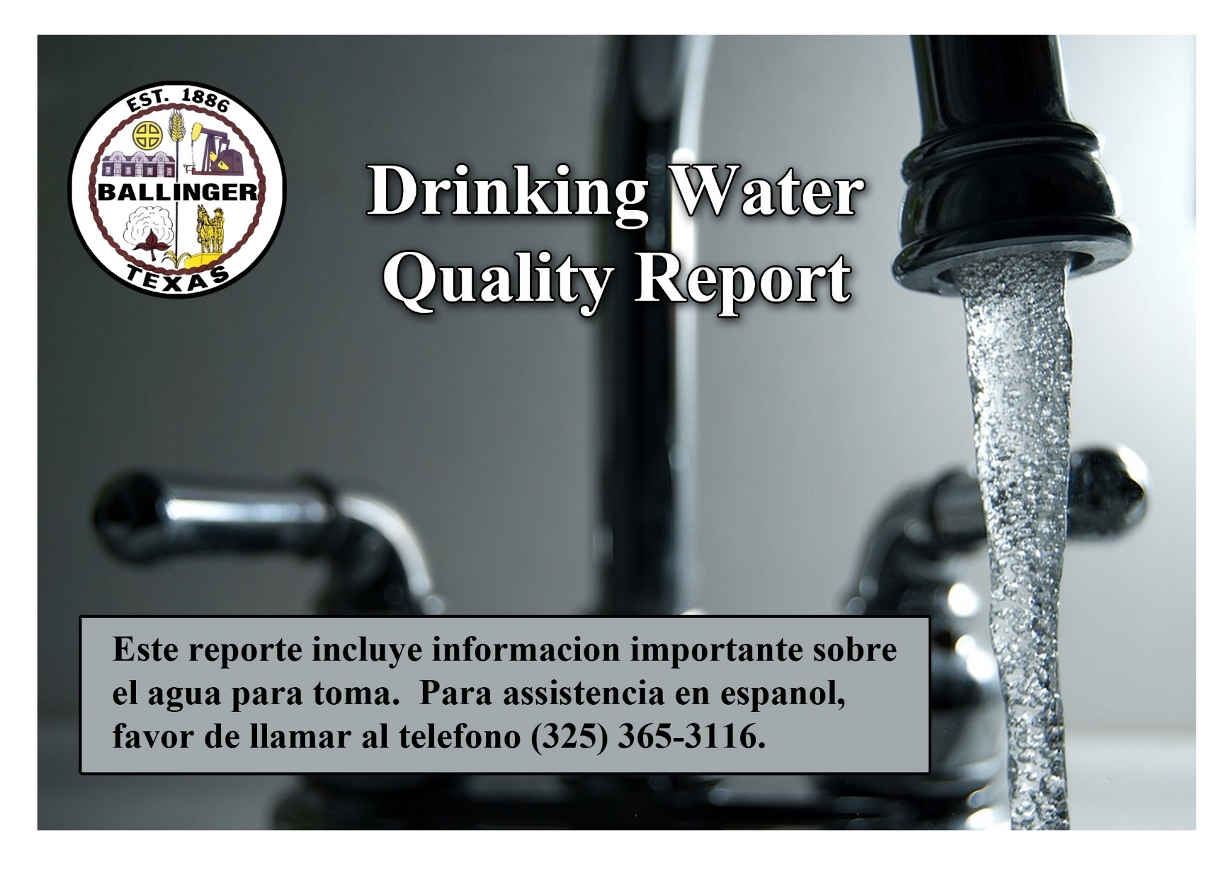
2023
Annual Water Quality Report for the period of
JANUARY 1, 2023 - DECEMBER 31, 2023
For More Information regarding this report contact:
Name: David Brem
Phone: 325-365-3116
Este reporte incluye informacion importante sobre el agua para tomar. Para asistencia en espanol, favor de llamar al telefono (325) 365-3116.

This is the City of Ballinger’s annual water quality report for the period of January 1 to December 31, 2022.
This report is intended to provide you with important information about your drinking water and the efforts made by the water system to provide safe drinking water.

The City of Ballinger uses surface water from Lake Ballinger and Lake O.H. Ivie. Sources of drinking water (both tap water and bottled water) include rivers, lakes, streams, ponds, reservoirs, springs and wells. As water travels over the surface of the land or through the ground, it dissolves naturally occurring minerals and, in some cases, radioactive material, and can pick up substances resulting from the presence of animals or from human activity.

Drinking water, including bottled water, may reasonably be expected to contain at least small amounts of some contaminants. The presence of contaminants does not necessarily indicate that water poses a health risk. More information about contaminants and potential health effects can be obtained by calling the EPA’s Safe Drinking Water Hotline at (800) 426-4791.

Contaminants that may be present in source water include:

- Microbial contaminants, such as viruses and bacteria, which may come from sewage treatment plants, septic systems, agricultural livestock operations and wildlife.

- Inorganic contaminants, such as salts and metals, which can be naturally occurring or results from urban storm water runoff, industrial or domestic wastewater discharges, oil and gas production, mining, or farming.

- Pesticides and herbicides, which may come from a variety of sources such as agriculture, urban storm water runoff, and residential uses.

- Organic chemical contaminants, including synthetic and volatile organic chemicals, which are by-products of industrial processes and petroleum production, and can also come from gas stations, urban storm water runoff, and septic systems.

- Radioactive contaminants, which can be naturally occurring or be the result of oil and gas production and mining activities.

In order to ensure that tap water is safe to drink, EPA prescribes regulations which limit the amount of certain contaminants in water provided by public water systems. FDA regulations establish limits for contaminants in bottled water which must provide the same protection for public health.

Contaminants may be found in drinking water that may cause taste, color, or odor problems. These types of problems are not necessarily causes for health concerns. For more information on taste, odor, or color of drinking water, please contact the system's business office.

You may be more vulnerable than the general population to certain microbial contaminants, such as Cryptosporidium, in drinking water. Infants, some elderly, or immunocompromised persons such as those undergoing chemotherapy for cancer; persons who have undergone organ transplants; those who are undergoing treatment with steroids; and people with HIV/AIDS or other immune system disorders, can be particularly at risk from infections. You should seek advice about drinking water from your physician or health care providers. Additional guidelines on appropriate means to lessen the risk of infection by Cryptosporidium are available from the Safe Drinking Water Hotline (800-426-4791).

If present, elevated levels of lead can cause serious health problems, especially for pregnant women and young children. Lead in drinking water is primarily from materials and components associated with service lines and home plumbing. We are responsible for providing high quality drinking water, but we cannot control the variety of materials used in plumbing components. When your water has been sitting for several hours, you can minimize the potential for lead exposure by flushing your tap for 30 seconds to 2 minutes before using water for drinking or cooking. If you are concerned about lead in your water, you may wish to have your water tested. Information on lead in drinking water, testing methods, and steps you can take to minimize exposure is available from the Safe Drinking Water Hotline or at http://www.epa.gov/safewater/lead.

Information about Source Water Assessments

A Source Water Susceptibility Assessment for your drinking water source(s) is currently being updated by the Texas Commission on Environmental Quality. This information describes the susceptibility and types of constituents that may come into contact with your drinking water source based on human activities and natural conditions. The information contained in the assessment allows us to focus source water protection strategies.

For more information about your sources of water, please refer to the Source Water Assessment Viewer available at the following URL: https://gisweb.tceq.texas.gov/swav/Controller/index.jsp?wtrsrc

Further details about sources and source-water assessments are available in Drinking Water Watch at the following URL: http://dww2.tceq.texas.gov/DWW/

Source Water Name |  | Type of Water | Report Status | Location
PURCHASED RAW SW FROM LK OH IVIE | CC FROM TX2210001 CITY OF ABILENE | SW | ACTIVE | LAKE O.H. IVIE
RWP I-3 (LAKE BALLINGER) | (LAKE BALLINGER) | SW | ACTIVE | LAKE BALLINGER

2023 Regulated Contaminants Detected

Lead and Copper
Definitions:
Action Level Goal (ALG): The level of a contaminant in drinking water below which there is no known or expected risk to health. ALGs allow for a margin of safety.
Action Level: The concentration of a contaminant which, if exceeded, triggers treatment or other requirements which a water system must follow.
Lead and Copper | Date Sample | MCLG | Action Level (AL) | 90th Percentile | # Sites Over AL | Units | Violation | Likely Source of Contamination
Copper | 09/13/2022 | 1.3 | 1.3 | <0.050 | 0 | ppm | N | Erosion of natural deposits; Leaching from wood preservatives; Corrosion of household plumbing
Lead | 09/13/2022 | 0.015 | 0.015 | <0.005 | 0 | ppb | N | Corrosion of household plumbing systems; Erosion of natural deposits

Water Quality Test Results
Definitions and Abbreviations: | The following tables contain scientific terms and measures, some of which may require explanation.
Action Level: | The concentration of a contaminant which, if exceeded, triggers treatment or other requirements which a water system must follow.
Action Level Goal (ALG): | The level of a contaminant in drinking water below which there is no known or expected risk to health. ALGs allow for a margin of safety.
Avg: | Regulatory compliance with some MCLs are based on running annual average of monthly samples.
Level 1 Assessment: | A Level 1 assessment is a study of the water system to identify potential problems and determine (if possible) why total coliform bacteria have been found in our water system.
Level 2 Assessment: | A Level 2 assessment is a very detailed study of the water system to Identify potential problems and determine (if possible) why an E. coli MCL violation has occurred and/or why total coliform bacteria have been found in our water system on multiple occasions.
Maximum Contaminant Level or MCL: | The highest level of a contaminant that is allowed in drinking water. MCLs are set as close to the MCLGs as feasible using the best available treatment technology.
Maximum Contaminant Level Goal or MCLG: | The Level of a contaminant in drinking water below which there is no known or expected risk to health. MCLGs allow for a margin of safety.
Maximum Residual Disinfectant level or MRD: | The highest level of a disinfectant allowed in drinking water. There is convincing evidence that addition of a disinfectant is necessary for control of microbial contaminants.
Maximum Residual Disinfectant level goal or MRDLG: | The level of drinking water disinfectant below which there is no known or expected risk to health. MRDLGs do not reflect the benefits of the use of disinfectants to control microbial contaminants.
MFL | Million Fibers per Liter (a measure of asbestos)
mrem: | millirems per year (a measure of radiation absorbed by the body)
na: | not applicable.
NTU | nephelometric turbidity units (a measure of turbidity)
pCi/L | picocuries per liter (a measure of radioactivity)
ppb: | micrograms per liter or parts per billion – or one ounce in 7,350,000 gallons of water.
ppm: | milligrams per liter or parts per million – or one ounce in 7,350 gallons of water.
ppq: | parts per quadrillion, or picograms per liter (pg/L)
ppt: | parts per trillion, or nanograms per liter (ng/L)
Treatment Technique or TT: | A required process intended to reduce the level of a contaminant in drinking water.

Regulated Contaminants
Disinfectants and Disinfection By-Products | Collection Date | Highest Level Detected | Range of Levels Detected | MCLG | MCL | Units | Violation | Likely Source of Contamination
Chlorite | 2023 | .946 | 0 - 0.946 | 0.8 | 1 | ppm | N | By-product of drinking water disinfection.
Haloacetic Acids (HAA5) | 2023 | 29 | 16.6 - 38 | No Goal for the total | 60 | ppb | N | By-product of drinking water disinfection.
‘*The value in the Highest Level or Average Detected column is the highest average of all HAA5 sample results collected at a location over a year’
Total Trihalomethanes (TTHM) | 2023 | 97 | 41.2-108 | No Goal for the total | 80 | ppb | Y | By-product of drinking water disinfection.
‘*The value in the Highest Level or Average Detected column is the highest average of all TTHM sample results collected at a location over a year’
Inorganic Contaminants | Collection Date | Highest Level Detected | Range of Levels Detected | MCLG | MCL | Units | Violation | Likely Source of Contamination
Arsenic | 2023 | 1 | 1.1 – 1.1 | 0 | 10 | ppm | N | Erosion of natural deposits; Runoff from  Orchards; Runoff from glass and electronics  production wastes
Barium | 2023 | 0.19 | 0.19 - 0.19 | 2 | 2 | ppm | N | Discharge from drilling wastes; Discharge from metal refineries; Erosion of natural deposits.
Cyanide | 2023 | 128 | 0 - 128 | 200 | 200 | ppb | N | Discharge from plastic and fertilizer factories;  Discharge from steel/metal factories.
Fluoride | 2023 | 0.2 | 0.19 - 0.19 | 4 | 4.0 | ppm | N | Erosion of natural deposits; Water additive which promotes strong teeth; Discharge from fertilizer and aluminum factories.
Nitrate [measured as Nitrogen] | 2023 | .219 | 0.219 - 0.219 | 10 | 10 | ppm | N | Runoff from fertilizer use; Leaching from septic tanks, sewage; Erosion of natural deposits.
Radioactive Contaminants | Collection Date | Highest Level Detected | Range of Levels Detected | MCLG | MCL | Units | Violation | Likely Source of Contamination
Beta/photon emitters | 2022 | 8.4 | 8.4 – 8.4 | 0 | 50 | pCi/L* | N | Decay of natural and man-made deposits
*EPA considers 50 pCi/L to be the level of concern for beta particles.

Uranium | 2022 | 1.9 | 1.9 – 1.9 | 0 | 30 | ug/l | N | Erosion of natural deposits
Synthetic organic  contaminants including  pesticides and herbicides | Collection Date | Highest Level Detected | Range of Levels Detected | MCLG | MCL | Units | Violation | Likely Source of Contamination
Atrazine | 2019 | <0.1 | 0.1 – 0.1 | 3 | 3 | ppb | N | Runoff from herbicide on row crops
Di (2-ethylhexyl) phthalate | 2019 | <0.5 | 0.5 – 0.5 | 0 | 6 | ppb | N | Discharge from rubber and chemical factories

UCMR5
Unregulated Contaminant | Collection Date | Average level  (µg/L) | Health-Based Reference Concentration (µg/L) (recommended, not required in the CCR) | Health Information Summary (recommended, not required in the CCR)
Lithium | 2023 | 62 | 9
PFBA | 2023-2024 | .009 | .005
PFBS | 2023-2024 | .003 | .003
PFHxS | 2023-2024 | .01 | .003
6:2 FTS | 2023-2024 | .006 | 1

Disinfectant Residual
Disinfectant Residual | Year | Average Level | Range of  Levels Detected | MRDL | MRDLG | Unit of  Measure | Violation (Y/N) | Source in Drinking Water
Total Chlorine | 2023 | 1.89 | 1.4-2.6 | 4 | 4 | ppm | N | Water additive used to control microbes.

Turbidity
 | Limit (Treatment Technique) | Level Detected | Violation | Likely Source of Contamination
Highest single measurement | 1 NTU | 2.19 | N | Soil runoff.
Lowest monthly % meeting limit | 0.3 NTU | 98% | N | Soil runoff.
Information Statement: Turbidity is a measurement of the cloudiness of the water caused by suspended particles. We monitor it because it is a good indicator of water quality and the effectiveness of our filtration.

Total Organic Carbon
The percentage of Total Organic Carbon (TOC) removal was measured each month and the system met all TOC removal requirements set, unless a TOC violation is noted in the violations section.
Violations Table
Public Notifications Rule
The Public Notification Rule helps to ensure that consumers will always know if there is a problem with their drinking water. These notices immediately alert consumers if there is a serious problem with their drinking water (e.g., a boil water emergency).
Violation Type | Violation Begin | Violation /End | Violation Explanation
PUBLIC NOTICE RULE LINKED TO VIOLATION | 04/08/2019 | 01/31/2023 | We failed to adequately notify you, our drinking water consumers, about a violation of the drinking water regulation.
PUBLIC NOTICE RULE LINKED TO VIOLATION | 07/05/2023 | 8/03/2023 | We failed to adequately notify you, our drinking water consumers, about a violation of the drinking water regulation

Total Trihalomethanes (TTHM)
Some people who drink water containing trihalomethanes in excess of the MCL over many years may experience problems with their liver, kidneys, or central nervous systems, and may have an increased risk of getting cancer.
Violation Type | Violation Begin | Violation /End | Violation Explanation
FAILURE SUBMIT OEL REPORT FOR TTHM | 06/24/2023 | 08/03/2023 | We failed to submit our operational evaluation level (OEL) report to our regulator. The report is needed to determine best treatment practices necessary to minimize possible future exceedences of TTHM.
MCL, LRAA | 01/01/2023 | 03/31/2023 | Water samples showed that the amount of this contaminant in our drinking water was above its standard (called a maximum contaminant level and abbreviated MCL) for the period indicated.
MCL, LRAA | 04/01/2023 | 06/30/2023 | Water samples showed that the amount of this contaminant in our drinking water was above its standard (called a maximum contaminant level and abbreviated MCL) for the period indicated.
MCL, LRAA | 07/01/2023 | 09/30/2023 | Water samples showed that the amount of this contaminant in our drinking water was above its standard (called a maximum contaminant level and abbreviated MCL) for the period indicated.
MCL, LRAA | 10/01/2023 | 12/31/2023 | Water samples showed that the amount of this contaminant in our drinking water was above its standard (called a maximum contaminant level and abbreviated MCL) for the period indicated.

